05/09/13

CAP 223

Visual Effects Process
Plan of Instruction

Effective Date: Spring 2013 Version Number: 2013-1

COURSE DESCRIPTION:

This course introduces students to how visual effects are created in a workplace environment. Emphasis is placed on the study of a typical VFX house hierarchy and the pipeline structure. Topics include data flow, standardization, work hierarchy, internal and external interactions and work ethics. Upon completion, the student should be able to understand the inner workings of a VFX company and their role inside it.

CREDIT HOURS

Theory Credit Hours 2 hours
Lab Credit Hours 1 hour
Total Credit Hours 3 hours

NOTE: Theory credit hours are a 1:1 contact to credit ratio. Colleges may schedule lab hours as 3:1 and/or 2:1 contact to credit ratio. Clinical hours are 3:1 contact to credit ratio. (Ref Board Policy 705.01)

PREREQUISITE COURSES

None

CO-REQUISITE COURSES

As determined by college.

PROFESSIONAL COMPETENCIES

- Describe the production pipeline elements and operations.
- Describe how to put pipeline theory into practice.

INSTRUCTIONAL GOALS

- Cognitive – Comprehend principles and concepts related to a pipelined visual effects work.

- Psychomotor – Apply principles of visual effects pipeline.

- Affective – Value the importance of organized and structured work inside a visual effects company.

STUDENT OBJECTIVES

Condition Statement: Unless otherwise indicated, evaluation of student’s attainment of objectives is based on knowledge gained from this course. Specifications may be in the form of, but not limited to, cognitive skills diagnostic instruments, manufacturer’s specifications, technical orders, regulations, national and state codes, certification agencies, locally developed lab/clinical assignments, or any combination of specifications.

STUDENT LEARNING OUTCOMES

MODULE A – PIPELINE THEORY AND ELEMENTS
MODULE DESCRIPTION – This module instructs students on production pipeline elements and operations. Topics include a pipeline overview, color space, alternate rendering, naming conventions, the production line, working as a team, Softimage use, and elements of the visual effects industry.
PROFESSIONAL COMPETENCIES | PERFORMANCE OBJECTIVES | KSA
A1.0 Describe the production pipeline elements and operations. | A1.1 This competency is measured cognitively.  A1.1 Value the importance of complying with a work hierarchy. | 3  A
LEARNING OBJECTIVES |  | KSA
A1.1.1 Identify general pipeline flowchart elements.  A1.1.2 Explain the color space principles.  A1.1.3 Identify typical color profiles.  A1.1.4 Describe the linear mode workflow.  A1.1.5 Explain Arnold rendering workflow.  A1.1.6 Explain POV ray rendering workflow.  A1.1.7 Describe naming conventions rules.  A1.1.8 Identify flow of data in production line.  A1.1.9 Explain the pros and cons of working in a team.  A1.1.10 Describe how to use reference model in Softimage.  A1.1.11 Identify key job positions in a visual effect company.  A1.1.12 Describe what it is like to work in the visual effects industry. |  | 2  2  3  4  2  2  3  2  3  3  4  3
MODULE A OUTLINE:
- Pipeline overview
- Color space
- Color profiles
- Linear workflow
- Alternate renderer
- Arnold render engine
- POV ray render engine
- Naming conventions
- The production line: task and data.
- Working as team
- Reference models in Softimage
- Using passes and partitions in Softimage
- Visual effects artist job positions and profile
- Visual effects industry outline

MODULE B – PIPELINE AT WORK: SIMULATED PRODUCTION PROJECTS
MODULE DESCRIPTION – This module puts students into practice with simulated projects. Topics include production management tools Shotgun and Perforce, and creating CGI working scenes.
PROFESSIONAL COMPETENCIES | PERFORMANCE OBJECTIVES | KSA
B1.0 Describe how to put pipeline theory into practice. | B1.1 Create a CGI working scene with linear workflow.  B1.1 Create a CGI working scene in a coordinated team while using referenced models. | 3  3
LEARNING OBJECTIVES |  | KSA
B1.1.1 Explain what production management software is used for.  B1.1.2 Describe using Shotgun software.  B1.1.3 Describe using Perforce software.  B1.1.4 Explain how to create a CGI working scene with linear workflow.  B1.1.5 Explain how to create a CGI working scene in a coordinated team while using referenced models. |  | 2  2  2  3  3
MODULE B OUTLINE:
- Production management tools
- Shotgun
- Perforce
- Simulated case A
- Simulated case B

LEARNING OUTCOMES Table of specifications
The table below identifies the percentage of learning objectives for each module. Instructors should develop sufficient numbers of test items at the appropriate level of evaluation.

 | Limited Knowledge and Proficiency | Moderate Knowledge and Proficiency | Advanced Knowledge and Proficiency | Superior Knowledge and Proficiency
KSA | 1 | 2 | 3 | 4
Module A |  | 42% | 42% | 16%
Module B |  | 60% | 40%

The KSA is NOT determined by the verb used in the learning objective, but rather in the context in which the verb is used and the depth of knowledge and skills required.

Example: Three KSA levels using the same verb (describe):
KSA 1 – Describe three characteristics of metamorphic rocks. (Simple recall)
KSA 2 – Describe the difference between metamorphic and igneous rocks. (requires cognitive processing to determine the differences in the two rock types)
KSA 3 – Describe a model that you might use to represent the relationships that exist within the rock cycle. (requires deep understanding of rock cycle and a determination of how best to represent it)

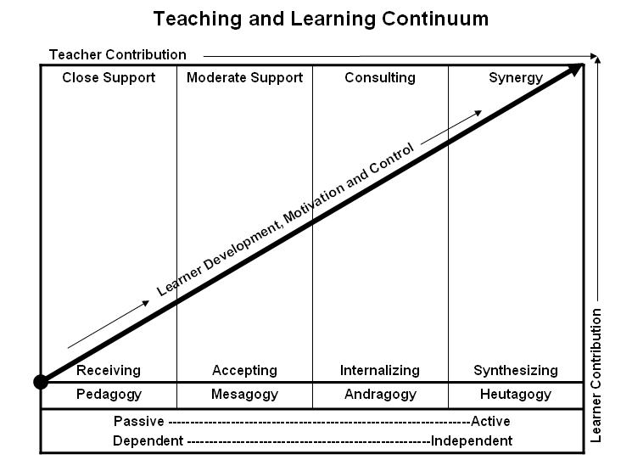
Learner’s Knowledge, Skills and Abilities
Indicator | Key Terms | Description
1 | Limited Knowledge and Proficiency | - Recognize basic information about the subject including terms and nomenclature.  - Students must demonstrate ability to recall information such as facts, terminology or rules related to information previously taught.  - Performs simple parts of the competency. Student requires close supervision when performing the competency.
2 | Moderate Knowledge and Proficiency | - Distinguish relationships between general principles and facts. Adopts prescribed methodologies and concepts.  - Students must demonstrate understanding of multiple facts and principles and their relationships, and differentiate between elements of information. Students state ideal sequence for performing task.  - Performs most parts of the competency with instructor assistance as appropriate.
3 | Advanced Knowledge and Proficiency | - Examines conditions, findings, or other relevant data to select an appropriate response.  - The ability to determine why and when a particular response is appropriate and predict anticipated outcomes.  - Students demonstrate their ability to seek additional information and incorporate new findings into the conclusion and justify their answers.  - Performs all parts of the competency without instructor assistance.
4 | Superior Knowledge and Proficiency | - Assessing conditions, findings, data, and relevant theory to formulate appropriate responses and develop procedures for situation resolution. Involves higher levels of cognitive reasoning.  - Requires students to formulate connections between relevant ideas and observations.  - Students apply judgments to the value of alternatives and select the most appropriate response.  - Can instruct others how to do the competency.  - Performs competency quickly and accurately.
A | Affective Objective | - Describes learning objectives that emphasize a feeling tone, an emotion, or a degree of acceptance or rejection.  - Objectives vary from simple attention to selected phenomena to complex but internally consistent qualities of character and conscience.  - Expressed as interests, attitudes, appreciations, values, and emotional sets or biases.

